Article

Development and experimental validation of a novel prognostic signature for gastric cancer

Chengcheng Liu1,4†, Yuying Huo5†, Yansong Zhang6†, Fumei Yin7†, Taoyu Chen8, Zhenyi Wang1,3, Juntao Gao1,3, Peng Jin7*, Xiangyu Li5*, Minglei Shi1,4*, Michael Q. Zhang1,2,3,4*

|  |
| --- |
| **Citation:** To be added by editorial staff during production.  Academic Editor: Firstname Lastname  Received: date  Accepted: date  Published: date  **Publisher’s Note:** MDPI stays neutral with regard to jurisdictional claims in published maps and institutional affiliations.    **Copyright:** © 2022 by the authors. Submitted for possible open access publication under the terms and conditions of the Creative Commons Attribution (CC BY) license (https://creativecommons.org/licenses/by/4.0/). |

1 MOE Key Laboratory of Bioinformatics; Bioinformatics Division and Center for Synthetic & Systems Biology, BNRist, Tsinghua University, Beijing 100084, China.

2 Department of Biological Sciences, Center for Systems Biology, University of Texas at Dallas, 75080, USA.

3 Department of Automation, Tsinghua University, Beijing 100084, China

4 School of Medicine, Tsinghua University, Beijing 100084, China.

5 School of Software Engineering, Beijing Jiaotong University, Beijing 100044, China.

6 School of Life Sciences, Peking University, Beijing 100871, China.

7 Senior Department of Gastroenterology, First Medical Center of Chinese PLA General Hospital, Beijing, China

8 Department of Bioinformatics, School of Basic Medicine, Peking University Health Center, Beijing, China.

**\*** Correspondence: jinpeng@301hospital.com.cn(P.J.); lixiangyu@bjtu.edu.cn(X.Y.L.); shiml79@mail.tsinghua.edu.cn(M.L.S.); michael.zhang@utdallas.edu(M.Q.Z.)

† These authors contributed equally to this work.

**Simple Summary:** This study developed and experimentally validated a prognostic risk gene signature (PRGS). This is a stable and robust signature for assessing the prognosis of gastric cancer.

**Abstract:**

**Background:** Gastric cancer is a malignant tumor with high morbidity and mortality. Therefore, accurate recognition of prognostic molecular markers is the key to improving efficacy and prognosis. **Methods**: In this study, we developed a stable and robust signature through a series of processes of machine learning approaches. We performed multiple analyses through consensus clustering and binary classification to assess the robustness of the PRGS in the other independent datasets. This PRGS was further experimentally validated in clinical samples and gastric cancer cell line. Besides, we also detected tumor purity, immune cell infiltration, and oncogenic mutation status of high- and low- PRGS groups.

**Results:** PRGS is an independent risk factor for overall survival and performs reliable and robust utility. Additionally, this PRGS exhibits superior accuracy than most traditional clinical markers, including molecular features, and other published signatures. Notably, PRGS proteins promote cancer cell proliferation by regulating cell cycle. Besides, the high-risk group displays lower tumor purity, higher immune cell infiltration, and lower oncogenic mutation than the low-PRGS group.

**Conclusion:** This PRGS could be a powerful and robust tool to improve clinical outcomes for individual gastric cancer patients.

**Keywords:** Gastric cancer; Prognostic signature; Tumor microenvironment; Oncogenic mutation; Clinical outcomes; Machine learning.

1. Introduction

Gastric cancer (GC) is a leading cause of cancer morbidity and mortality worldwide [1]. According to GLOBOCAN 2020, there were about 1 089 103 new cases of gastric cancer patients (5.6% of the total cancer burden) [1]. Disease progression and lack of effective treatment cause most of the mortality [2]. Therefore, preventing “high-risk” GC is the key to improving clinical outcomes. The tumor, node, metastasis (TNM) classification and American Joint Committee on Cancer (AJCC) classification [3] are commonly used methods to assess the risk and treatment demand for patients in the clinical setting. Nevertheless, due to the limitation of the current grading system, it cannot provide the best clinical treatment for patients, such as in the clinic, the decision of adjuvant chemotherapy (ACT) is mainly dependent on the clinical-pathological stage rather than molecular biological characteristics [4]. This approach is insufficient and may result in latent overtreatment or undertreatment. Hence, in the era of individualized treatment, it is imperative to identify effective biomarkers to optimize the prognosis of GC.

The ideal biomarker should have consistent expression within and between tumor tissues to perform stably among all patients. Hence, a multigene signature may be an effective approach to address this heterogeneity. To date, there are three categories of clinically important GC markers, CEA, CA19-9, and CA72-4 with positive rates of 21.1 %, 27.8%, and 30.0%, respectively [5]. However, it is present in a limited number of patients of GC, and the sensitivity and specificity of these biomarkers are not sufficient. With the development of bioinformatics technology, many prognostic biomarkers have been published [6-8]. Unfortunately, most of the identified biomarkers failed in the validation.

GC is a heterogeneous malignant disease. Histologically, the human gastric mucosa can be divided into three zones, i.e., the cardiac zone, the fundus/corpus zone, and the pyloric zone [9-10]. These zones differ vastly in their histology, regeneration rates, and profiles [11]. And there are different morbidity and mortality among GC in these three zones. It is believed that GC patients in the cardiac zone have the worst prognosis. As the patients’ age progressed, the location of gastric cancer moved upward, and the incidence of occurring in the cardiac zone increased [12]. The composition of cell types within them is also discrepant. For instance, the quantities of gastric parietal cells have considerable differences in these three zones. Namely, parietal cells account for 25%, 50-100%, and 0-1% of all cells in the cardiac zone, the fundus/corpus zone, and the pyloric zone, respectively [12]. Of note, most researchers who investigated gastric cancer biomarkers ignored the differences between these three zones and analyzed them as if all gastric cancers are of one single area. Hence, it's essential to construct gene co-expression networks and select prognostic-related genes separately for GC data in these three zones.

In this work, we attempted to computationally develop and experimentally validate a prognostic risk gene signature with 1,226 GC patients from three independent public datasets (Table S1-S4), gastric cancer cell line, and several clinical samples to assess the prognosis, tumor growth, and molecular characterization in GC. A multi-step procedure of machine learning approaches was performed to develop and cross-validate the prognostic risk gene signature (PRGS) model based on the co-expression networks of GC in the cardiac zone, the fundus/corpus zone, and the pyloric zone. This PRGS may help optimize precision treatment and further improve the clinical outcomes of GC patients.

2. Materials and Methods

2.1. Data acquisition and processing

In this study, we use three independent public datasets including 1,226 GC patients were got from the UCSC Toil Recompute Compendium of The Cancer Genome Atlas TARGET and Genotype Tissue Expression project datasets (TCGA target GTEx, primary_site = stomach) [13] and Gene Expression Omnibus (GEO) (Table S1-S4). These datasets (TCGA target GTEx, GSE66229, GSE15459) encompassing complete overall survival (OS) information were used. Among these, we converted the RNA-seq raw read count from the TCGA target GTEx database to transcripts per kilobase million (TPM) and then log-2 transformed, the data has been removed batch effects among these patients[14]. We retrieved GSE15459 and GSE66229 from the Affymetrix® GPL570 platform

(Human Genome U133 Plus 2.0 Array). We selected the most highly expressed probe for each gene to ensure reliable results in consensus clustering and we reserved all probes of each gene to ensure accurate results in Binary classification.

The ATAC-seq and somatic variation data were obtained from the database of the Genomic Data Commons Data Portal (https://portal.gdc.cancer.gov/).

2.2. Human tissue specimens

In this study, the gastric tissues were approved by the Department of Gastroenterology, Seventh Medical Center of Chinese PLA General Hospital, Beijing, China, on June 1st, 2022. Overall, one advanced GC sample, an early GC sample, and a normal gastric sample were collected. All patients provided written informed consent, and Ethnics committee of PLA General Hospital has also approved our research.

2.3. Differentially expressed analysis and weighted correlation network analysis

DEGs between cancer and normal samples were detected by the edgeR [15]. The genes with absolute log2(fold change) ≧1.5 were considered to be the significant differentially expressed genes(DEGs) between tumor and normal tissues. The volcano plots of upregulated or downregulated genes were generated by the ggplot2 R package. And the Venn diagram was plotted by the VennDiagram R package.

The co-expression gene networks were constructed by the WGCNA package [16]. To recognize modules of the cardiac zone, the fundus/corpus zone, and the pyloric zone significantly correlated clusters, the module that displayed the highest correlation was selected.

2.4. Construction of the co-expression Network

The brown, purple, and salmon modules of the result of WGCNA were respectively used for the edges signifying the correlations in the cardiac zone, the fundus/corpus zone, and the pyloric zone. The filter criterion of a weight value was set to greater than 0.02.

A total of 25 350, 1 819, 706 edges and 308, 69, 54 nodes correlated with these zones separately were obtained and processed in Cytoscape 3.8.1 [17]. To construct the network and select the hub genes, Cytoscape software was used with CytoHubba method[18].

2.5. PRGS signature generation

LASSO is a regularization and dimensionality reduction technique combined with Cox models, which can be applied in biomarker screening [19]. To identify the hub genes, the top25 genes of the co-expression network from the cardiac zone, the fundus/corpus zone, and the pyloric zone by Cytoscape, respectively, were inputted into the LASSO-Cox regression [19]. To ensure the stability of the gene and the model, this procedure is repeated 1000 times. Then, the regression coefficients of each gene were calculated (Table S5). Ultimately, genes with positive regression coefficients were selected. And four genes (APOB, VCAN, ABCA6, CTSF) whose P-value of Kaplan–Meier analysis is also <0.05 were identified to generate the PRGS model. The PRGS risk score of GC patients was calculated by the formula: PRGS score= $\sum_{k=1}^{4}{\left({4 \atop 1}\right)}$ βk X RNAk.

In this formula, k means genes in the PRGS, we use k = 1,2,3,4 to index over the genes in PRGS, β value was the multivariate Cox regression coefficient; RNAk means the expression level of gene k of each patient.

2.6. Chromatin Accessibility Analysis

The peak regions on chromosomes were shown by the R package chromosome locator. Using the R-packaged ChIPseeker alignment can be mapped to peaks in the TSS region to build a signature matrix. Peak position annotation and motif enrichment analysis were performed using HOMER (V4.10). In the range of ±1 kb around TSS, the peak overlapping the gene initiator was considered as the peak of gene regulation.

2.7. Consensus clustering

This process is accomplished through the ConsensusClusterPlus package [20]. We subsample 80% of the samples, and then use the k-means algorithm to divide each subsample into k (K=9) according to the Euclidean distance. This procedure is repeated 1000 times. Finally, using the PAC with the smallest K value, the optimal cluster (K=2) is derived.

2.8. Binary classification

1) We pre-processed GSE66229 data and selected the top5 genes from the three generated co-expression networks of the three zones’ expression spectrum matrix, then divided the data into normal and tumor samples. We also generated GSE66229 data and generated respective PRGS, CEA [38] and GCscore [6] expression spectrum matrix.

2) We performed 5-Fold Cross Validation using the Logistic Regression classifier (LR) and the Random Forest classifier (RF) on the GSE66229 and computed the ROC curve for each fold. We then calculated the means of every fitting curve to generate the plot. Then divided the data into five subsets based on sample tags “Tumor/Normal”, “Stage 1/Normal”, “Stage 2/Normal”, “Stage 3/Normal”, “Stage 4/Normal”. Details of the data are shown in supplementary data S4.

The parameters were set as follows: RF, max_depth=5, n_estimators=5, random_state=123; LR, solver='liblinear', penalty='l2', C=1.0. The rest were set as default. We trained and validated each fold and calculated respective FPR, TPR and AUC. We fit each result into the ROC curve by np.interp and take the means of all fitting curves to craft the figure.

2.9. Haematoxylin-eosin (HE) and immunohistochemistry (IHC)

For HE staining, 4% paraformaldehyde solution was used to fix GC tissues. After 24h, GC tissues was dewaxed in xylene, dehydrated in ethanol, and subjected to hematoxylin staining (5min), dehydrated in eosin solution (10s), dehydrated in graded alcohol, removed in xylene, and sealed with neutral glue. It was observed and photographed with a microscope (Olympus, Japan).

For IHC, 5% bovine serum was used to incubate sections. Then it was mixed with primary antibodies (anti-APOB, 1:100; anti-VCAN,1:100; anti-ABCA6, 1:200 and anti-CTSF, 1:200, Abcam, UK) and a secondary antibody (1:800, Abcam, UK). Then, it was stained with a DAB kit and photographed with an optical microscope (Olympus, Japan).

2.10. Cell culture, transfection, and immunostaining

GES-1 gastric cancer cells (a gift from Prof. Jun Qin) were cultured with 5% CO2 at 37°C in Dulbecco’s modified Eagle’s medium (DMEM) (Thermo Fisher, C11995500BT) with 20% FBS and 100 mg/mL penicillin/streptomycin.

For siRNA treatment, Lipofectamine™ 3000 Transfection Reagent (Thermo Fisher, L3000001) was used to transfect cells with standard procedure.

For immunostaining, poly-L-lysine-coated coverslips were used to culture cells for 72h to perform the siRNA transfection, 4% paraformaldehyde was used to fix cells for 10 minutes and washed with PBSTr buffer (PBS plus 0.1% Triton X-100, Sigma-Aldrich, T8787). Cells were incubated with anti-phosphorylated Histone 3 (pH3) antibody overnight at 4°C. Cells were incubated with secondary antibody at room temperature and washed with PBSTr buffer. Then 0.01mg/mL DAPI and Vectashield Antifade Mounting Medium(Vector Laboratories, H-1200) were used to incubate cells and mount, respectively.

2.11. Flow cytometric analysis

For flow cytometric analysis of cell cycle with propidium iodide (PI) staining, a standard procedure was used [21].

2.12. Quantitative real-time PCR

Eastep Super Total RNA Extraction Kit (Promega, LS1040) was used to extract the total RNA of siRNA-treated GES-1 cells. Eastep RT Master Mix Kit (Promega, LS2050) was used to synthesize the cDNA. Applied Biosystems 7500 real-time PCR system (Thermo Fisher) was used to perform Real-time PCRs with PowerUp SYBR Green Master Mix (Thermo Fisher, A25776). Comparative CT method and Graphpad Prism 8 (GraphPad Software, La Jolla, CA, USA) were used to analyze the data. All experiments were repeated three times.

2.13. Cells infiltration estimation

ESTIMATE [22] and CIBERSORT [23] were used to evaluate immune infiltrates. The immune scores, stromal scores, and tumor purity were calculated by the ESTIMATE algorithm. CIBERSORT [23] was used to analyze the levels of infiltrating immune and stromal cells.

2.14. Tumor mutation status analysis

Maftools was used to calculate significantly mutated genes (p < 0.05) between the low- and high-PRGS groups [24]. One-side z-test and two-side Chi-square test were used to calculate the statistical test for the proportion of mutation (p < 0.05).

2.15. Function enrichment analysis

Functional enrichment analysis was performed on DEGs and peak-related genes. The possible peak-related genes of GO/KEGG enrichment were used to analyze the ClusterProfiler package in R [25].

Gene Ontology (GO) and the Kyoto Encyclopedia of Genes and Genomes (KEGG) database were used to annotate the tumor-related pathways. And Gene Set Variation (GSVA) method [26] was used to enrich the pathways. We used the enrichment score of GSVA to obtain the expression pathway of PRGS.

3. Results

3.1. Construction of the gene modules

The workflow of this work is shown in Figure 1.

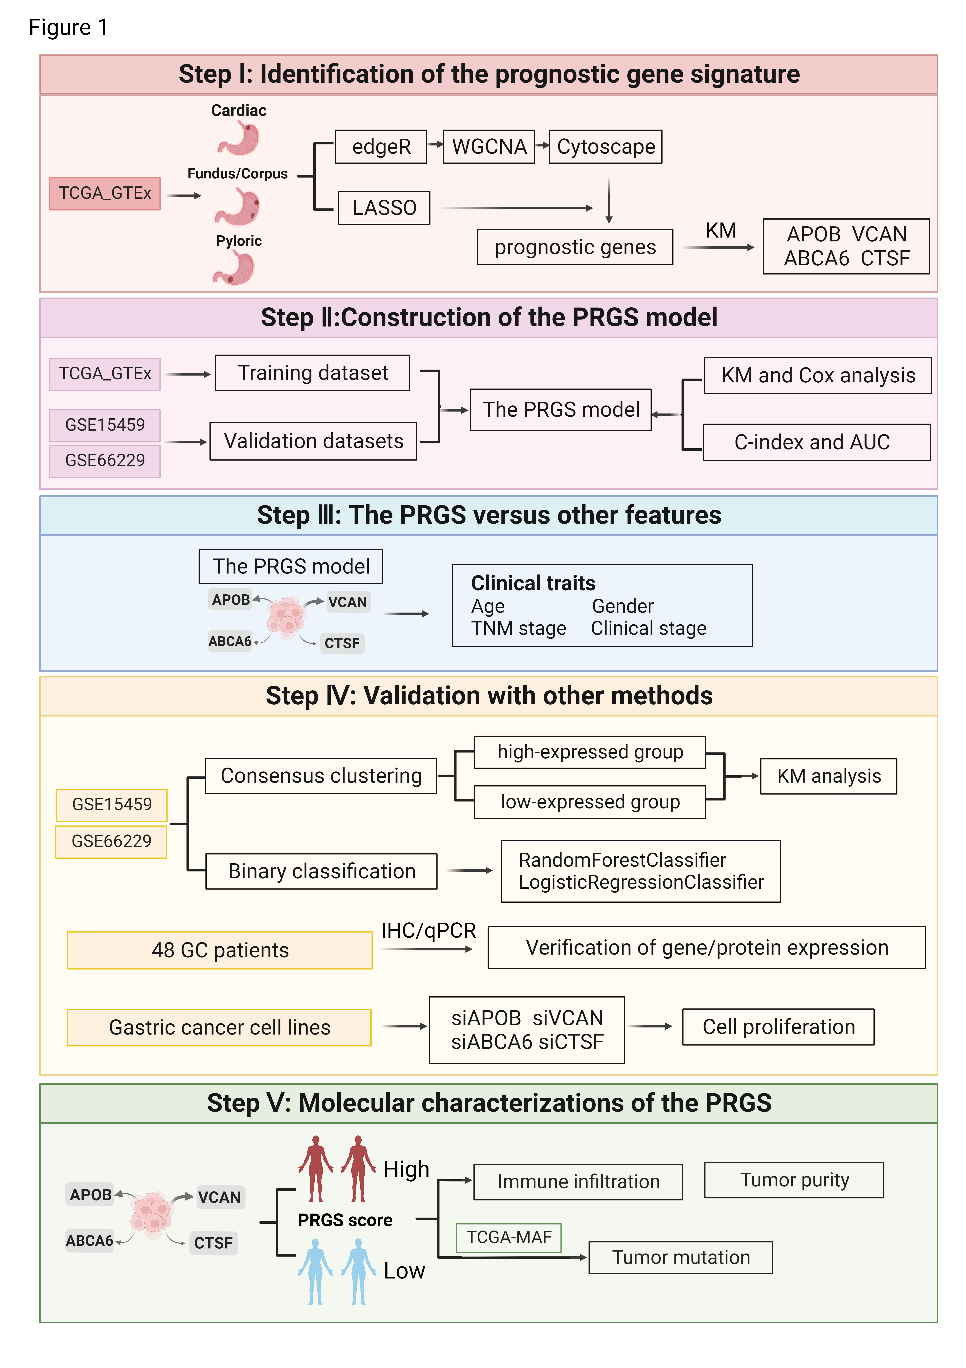

**Figure 1.** The overall design of this study.

First, we identified the differentially expressed genes (DEGs) in the TCGA target GTEx with the edgeR package independently to screen DEGs in normal samples and GC samples in the cardiac zone, the fundus/corpus zone, and the pyloric zone. For GC in the cardiac zone, 1498 upregulated and 883 downregulated DEGs were identified. A total of 1661 upregulated and 826 downregulated DEGs were found between normal and GC in the fundus/corpus zone. There were 1542 upregulated, and 889 downregulated DEGs for GC in the pyloric zone compared with normal samples (Table S5). The distributions of DEGs were shown by volcano plots (Figure 2A). There 1553 DEGs were shared among the GC samples in these three zones (Figure 2B). We adopted GO and KEGG enrichment analysis methods to investigate the annotation of DEGs for them. And DEGs of GC samples in the cardiac zone were mainly enriched in sensory perception (GO:0050907), the collagen-containing extracellular matrix (GO: 0062023), sarcomere (GO:0030017), and olfactory transduction. Sensory perception (GO:0050907), ion channel complex (GO:0034702), olfactory receptor activity (GO:0004984), and olfactory transduction were detected in GC samples in the fundus/corpus zone. In addition, the GC samples in the pyloric zone are highly associated with digestion (GO:0007586), collagen-containing extracellular matrix (GO:0062023), receptor-ligand activity (GO:0048018), and neuroactive ligand-receptor interaction (Figures S1A-B).

To further identify the gene modules related to GC in the cardiac zone, the fundus/corpus zone, and the pyloric zone, the WGCNA method [16] was applied. We assure a scale-free network (soft threshold = 3) with high scale independence and low mean connectivity (near 0) (Figure S1C). DEGs from the GC samples in the cardiac zone, the fundus/corpus zone, and the pyloric zone were respectively divided into 22 modules by cluster analysis (Figure 2C). The brown module related to GC in the pyloric zone was the most significant (cor = 0.76, p = 2e-112). For GC in the cardiac zone and the fundus/corpus zone, the purple and salmon modules were chosen according to the correlation (cor = 0.22, 0.33; p = 3e-8, 1e-16).

We selected the brown, purple, and salmon modules for the edges, respectively, presenting the correlations in GC in the cardiac zone, the fundus/corpus zone, and the pyloric zone by the WGCNA algorithm [16]. The Cytoscape software [16] was used to visualize the gene co-expression networks [17], and the Cytohubba was used to select hub genes [18] (Figure 2D and Table S6). We also performed GO and KEGG enrichment analysis of the purple (correlated with the cardiac zone), salmon (correlated with the pyloric zone), and brown (correlated with the fundus/corpus zone) modules (Figure S2A-F).

We performed survival analysis of the genes from the co-expression networks of the three zones on GC patients in TCGA target GTEx and GSE66229 datasets (GSE15459 doesn't have information on the three zones). The results indicated that the top5 genes (APOA4, MS4A10, SLC28A1, AQP10, APOB) from the cardiac zone co-expression network correlated most significantly with the outcomes of GC patients in the cardiac zone compared to GC patients of the other two zones ( Figure S3A-B). The same is for patients with the GC in the fundus/corpus zone. The top5 genes (VCAN, COL1A2, FAP, PODNL1, SULF1) from the fundus/corpus zone co-expression network also displayed the vastest correlation with the fundus/corpus zone GC patients than GC patients of the other two zones ( Figure S3C-D). Meanwhile, we performed binary classification using Logistic Regression classifier (LR) and Random Forest classifier (RF) with the hub genes (APOA4, MS4A10, SLC28A1, AQP10, APOB) of GC in the cardiac zone as the feature genes to predict whether patients have GC and achieved highest AUC in patients with GC of the cardiac zone compared to the other two zones in GSE66229 datasets ( Figure S3E). The same is for the hub genes (VCAN, COL1A2, FAP, PODNL1, SULF1) of GC patients in the fundus/corpus zone ( Figure S3F). These results further indicated that discriminating against different zones of GC is of great importance.

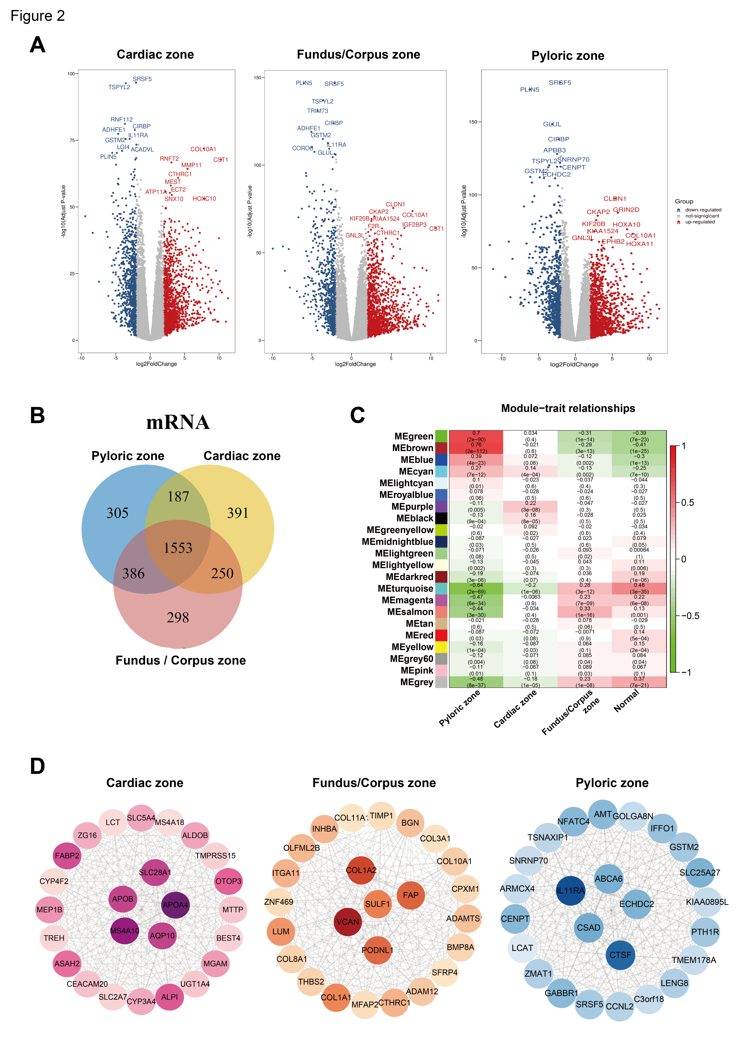

**Figure 2.** Identify co-expression networks of the cardiac zone, the fundus/corpus zone, and the pyloric zone. (A)Volcano plots of DEGs in the cardiac zone, the fundus/corpus zone, and the pyloric zone. Red and blue spots represent significant up- and down-regulated RNAs, respectively. The remark for the gene symbols represents the significant up- and down-regulated RNAs. (B)Venn diagram of the DEGs in the cardiac zone, the fundus/corpus zone, and the pyloric zone. Different colors indicate the GC in different zones. The numbers represent the common DEGs among the GC in different zones. (C) Correlation analysis between module eigengenes and the three zones. (D) Co-expression networks of the cardiac zone, the fundus/corpus zone, and the pyloric zone.

3.2. Construction and cross-validation of the PRGS model in gastric cancer cohorts

To further determine prognostic genes related to the three zones of GC, we have continued to generate predictive genes using the TCGA target GTEx and cross-validated these genes with two independent datasets (GSE66229, GSE15459). Based on the expression profiles of 25 genes respectively correlated with GC in the cardiac zone, the fundus/corpus zone, and the pyloric zone, LASSO Cox regression analysis [19] generated the predictive genes. This process was repeated 1000 times with the glmnet R package to ensure the stability of the gene [27]. In the LASSO regression, the partial likelihood of deviance reached the minimum value to obtain the optimal λ(Figure S4A). Six, four, and three genes from GC in the cardiac zone, the fundus/corpus zone, and the pyloric zone, respectively, with positive LASSO coefficients, were subjected to the log-rank test and the Kaplan-Meier curve (Figure 3A), which identified a final set of four genes. There are four genes with the maximum coefficient of GC in the three zones respectively, including APOB (p value=0.028, FDR=0.0042) correlated with GC in cardiac zone, VCAN (p value=9.2e-25, FDR= 0.0004) correlated with GC in fundus/corpus zone, and ABCA6 (p value=0.0028, FDR= 0.0042) as well as CTSF (p value=0.023, FDR= 0.023) correlated with GC in pyloric zone. For each of these four genes, the increased expression level was vastly associated with worse OS for gastric cancer patients (Figure 3A). Besides, these four genes (APOB, VCAN, ABCA6, CTSF) are included in the DEG lists in the GC data of respective zones in dataset GSE66229.

We next depict the PRGS expression level at single-cell resolution. We analyzed the scRNA-seq data derived from 29 gastric cancer and 11 normal gastric tissues[28]. After quantity control and removal batch effect, we obtained a total of 200,954 cells major comprising of lymphoid(CD8A and KLRD1 positive), plasma(TNFRSF17 positive), epithelial(CDH1 positive), macrophage(CD163 positive), fibroblast(FN1 and LUM positive), B cell(MS4A1 positive), mast cell(KIT positive) and pericytes(NOTCH3 positive)(Figure S4B-E and Figure S5A). As shown in Figure S5B, VCAN was expressed in macrophage and fibroblast; ABCA6 and CTSF were mainly expressed in fibroblast; APOB was expressed in epithelial cell(Figure S5B). We also observed that GC samples and GC samples in different Lauran classifications(Intestinal, diffuse, and mixed types) exhibited higher PRGS scores than normal samples (Figure S6A-D). We computed global PRGS scores for all cell types and found that fibroblast had the highest PRGS scores than other cell types(Figure S6D). VCAN and CTSF have been reported to be expressed by fibroblast, and PRGS(ABCA6, APOB, CTSF, VCAN) occur in many human diseases[29]-[35], but their role in GC has not been demonstrated clearly. Thus, they may be identified as new markers for GC.

We also identify the chromatin accessibility of these four genes; thus, we analyzed the relative enriched proportions of coding regions, intergenic regions, introns, exons, and upstream and downstream regions (Figure S7A-C) with ATAC-seq data from TCGA. Peaks annotation demonstrated that the peaks of these genes were more likely to locate in promotor regions (Figure S7D). We also performed motif enrichment and calculated potential regulatory TFs within the 200bp range of gene loci based on genes from the PRGS model with HOMER (Figure S8A) KEGG analysis of the peaks was also performed. (Figure S8B-E).

The risk score for each patient was then calculated using the expression matrix of these four genes (APOB, VCAN, ABCA6, CTSF) weighted by their regression coefficients in the cox model (Table S7). All patients were divided into high- and low-PRGS groups by the survminer package [36]. As can be seen from figure 3B, overall survival (OS) was significantly lower in the high-PRGS group relative to the low-PRGS group in the TCGA target GTEx training dataset and two validation datasets (all p < 0.05). In Figure S9A, we see the distribution of PRGS scores for the patient group, as well as the relationship between PRGS and survival time. The cut-off of high- and low- PRGS group is 50%.

We also evaluate PRGS in Lauren and WHO histotypes. The results shown in Figure S9B-D indicate that overall survival (OS) of all classifications was significantly lower in the high-PRGS group relative to the low-PRGS group in the TCGA target GTEx training dataset and two validation datasets (all p < 0.05) (The GSE66229 and GSE15459 only provide the information of Lauran classification). Then, we assessed the OS status in different TNM stage groups. As shown in Figure S10A-B and Figure S10D-E, high- PRGS group was tightly correlated with worse OS status in late stages (T3, T4, N2, N3) in TCGA target GTEx and in GSE66229(T2, T3, N1, N2, N3). High- PRGS group was vastly associated with worse OS status in M0 stages and most of the patients in these datasets were in M0 stage(Figure S10C, Figure S10F and Table S4).

We noticed that patients with high PRGS were distributed in all different stages and OS statuses (Figure S11), indicating that our PRGS model is prognosis-specific, capable of assessing the risk of GC patients regardless of stages and status, though clinically, it’s potentially used at later stages for precision.

To investigate whether the prognostic value of the PRGS based on the four genes is an independent risk factor, multivariate Cox regression analysis we performed, the results indicated that the PRGS was notably associated with OS compared with other clinical characteristics (age; sex, clinic stages, and T, N, M stages), thus validating that PRGS is robust in independently predicting GC prognosis (Figure 3C). Similarly, the PRGS is still an independent risk factor for OS in validation datasets (GSE66229, GSE15459) (Figure 3D). We further explored the performance of PRGS with other characters, we found that the performance of the PRGS was better than other factors, including gender (whether male or female), age, pathological stages (T1~4, N0~3, M0~M1) and clinical stages (Stage I~IV) in TCGA target GTEx, GSE66229, and GSE15459 Figure S12A-C).

The discrimination of the PRGS was measured by ROC analysis, with 1-, 3-, and 5-year AUCs of 0.601, 0.663, and 0.717 in TCGA target GTEx; 0.607, 0.709, and 0.707 in GSE66229; 0.657, 0.674, and 0.711 in GSE15459 (Figure 4A). And the C-index [95% confidence interval] of the PRGS was highest compared with other factors (gender; age; T, N, M; clinic stage) in the TCGA target GTEx cohorts (Figure S13).

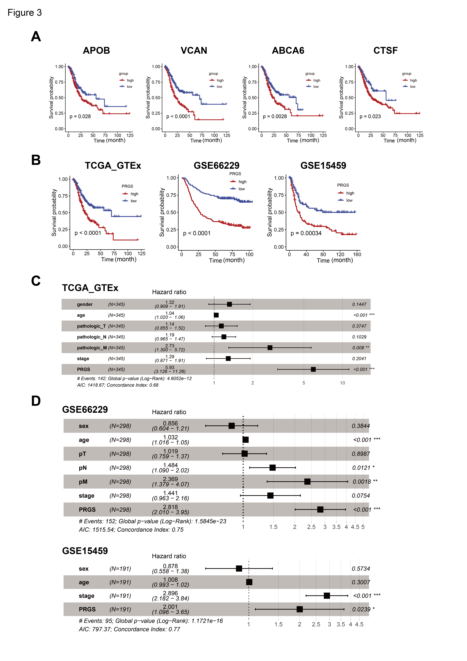

**Figure 3.** Cox and survival analysis of the PRGS model. (A) Kaplan–Meier curves of overall survival (OS) according to the PRGS in TCGA target GTEx. (B) Kaplan-Meier curves of OS according to the PRGS in TCGA target GTEx (log-rank test: p = 7.75e-05); GSE66229(log-rank test: p = 2.11e-11); GSE15459(log-rank test: p = 0.00034). (C) Multivariate Cox regression of PRGS regarding OS in TCGA target GTEx (n=345). (D) Multivariate Cox regression of PRGS regarding to OS in GSE66229(n=298), GSE15459(n=191). Statistic tests: two-sided Wald test. Data are presented as hazard ratio (HR) ± 95% confidence interval [CI].

3.3. PRGS are significantly related to clinical outcomes

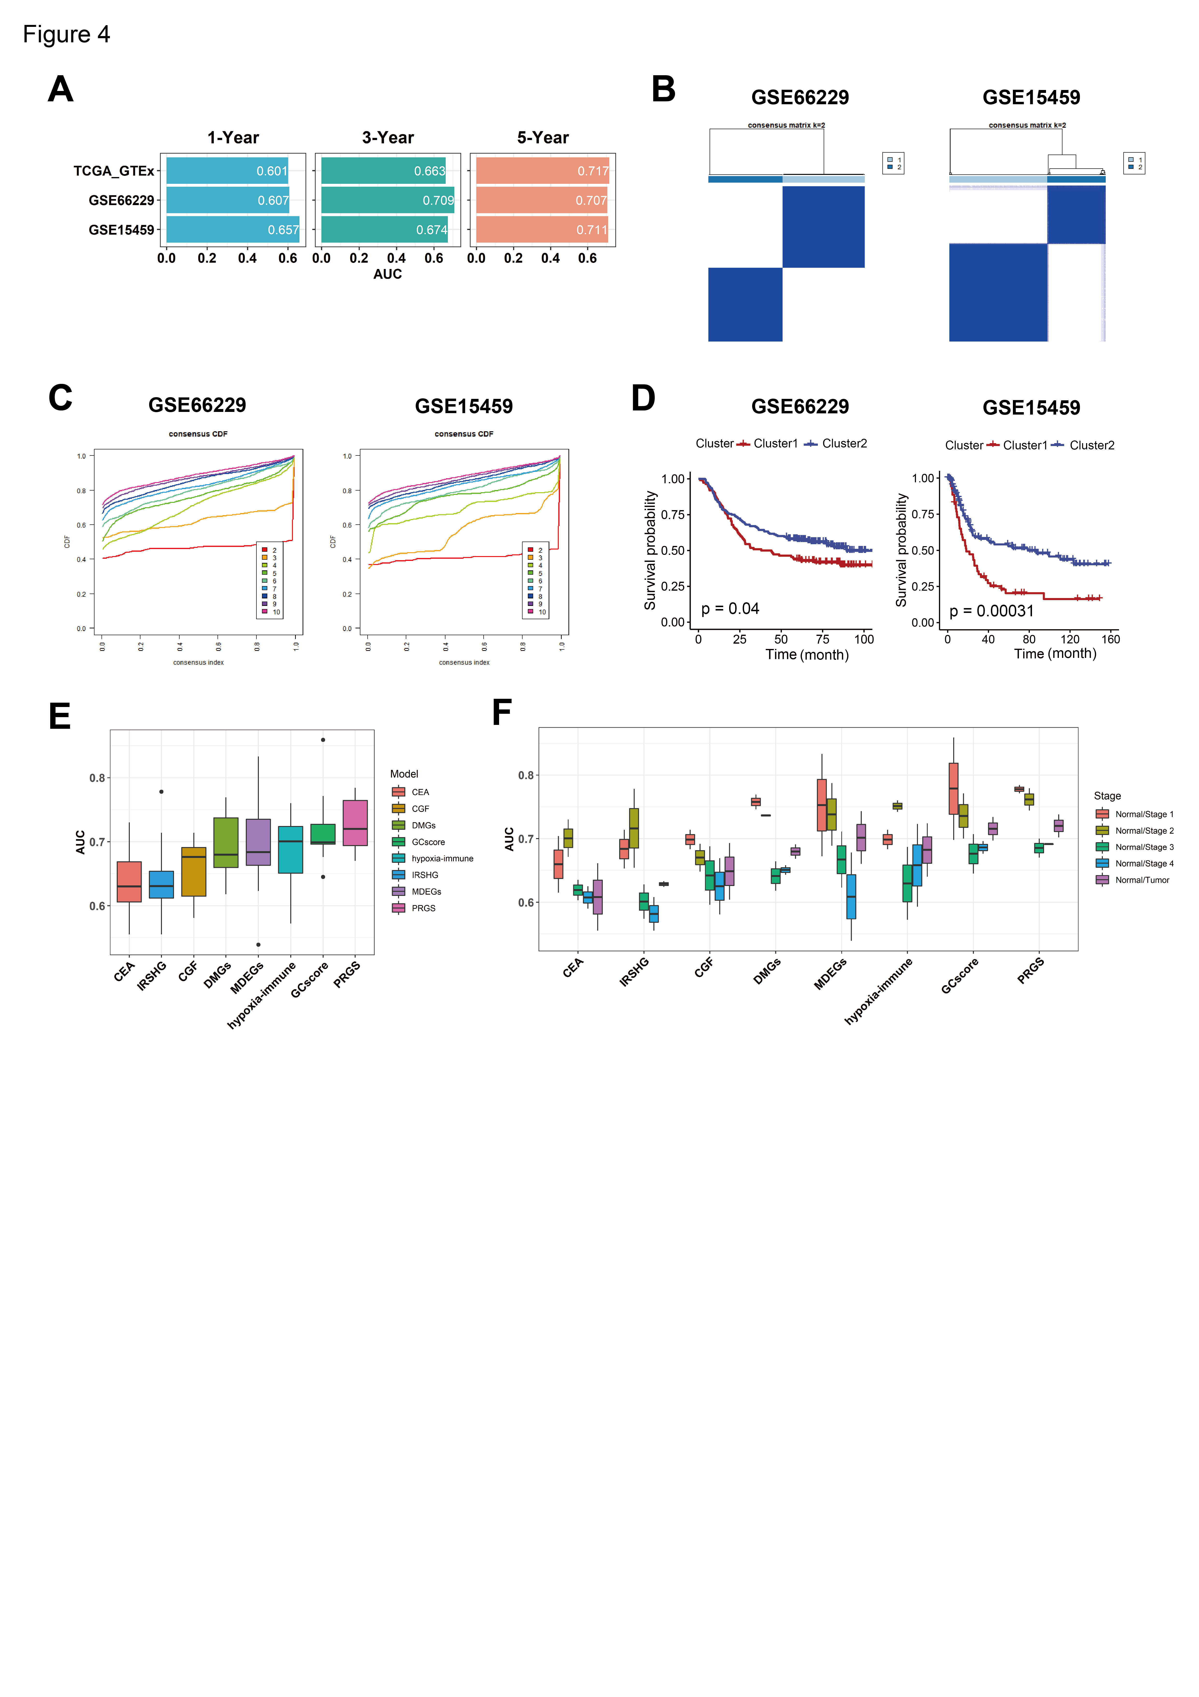To further validate the performance of our PRGS model, we conducted multiple analyses to evaluate the robustness of these four prognostic genes in the aforementioned independent datasets (GSE66229, GSE15459). First, through consensus clustering based on the four prognostic genes, We applied consensus cluster analysis to all GC samples, resulting in the division of the samples into k clusters(k = 2–9) clusters. The cumulative distribution function (CDF) curves of the consensus score matrix and proportion of ambiguous clustering (PAC) statistic indicated that the optimal number was obtained when k = 2[37]. we classified GC patients in GSE66229 and GSE15459 into Cluster 1 and Cluster 2 (Figure 4B-4C), respectively. The Kaplan–Meier curve indicated significant OS differences between the two clusters via the log-rank test, and the OS of patients in Cluster1 is significantly worse than Cluster2 (Figure 4D). As shown in Figure S14A and Figure S14E, the overall expression levels of the PRGS in Cluster1 are higher than in Cluster2 in both datasets. And when k=3 and 4, the Kaplan–Meier curve indicated patients in cluster1 with the lower PRGS expression level have vastly better OS than other clusters(Figure S14B-D and Figure S14F-H).Thus, for these four genes, the increased expression level was associated with a worse survival rate for gastric cancer patients. The observed consistency suggests that the expression levels of these four genes are vastly correlated with the OS of patients.

**Figure 4.** Evaluation of the PRGS signature. (A) A time-dependent ROC analysis for predicting OS at 1, 3, and 5 years in TCGA target GTEx, GSE66229, GSE15459. (B) The consensus score matrix of all samples in GSE66229 and GSE15459 when k = 2. A higher consensus score between two clusters indicates they are more likely to be grouped into the same cluster in different iterations.(C) The CDF curves of consensus matrix for each k. (D) Kaplan–Meier analysis showed that patients in Cluster 1 exhibited worse OS in both the GSE66229 (p=0.04) and GSE15459 (p=0.00031) cohort. (E) BoxPlot of AUC of two classifiers (LR, Logistic Regression; RF, Random Forest) with eight gene signatures as features in GSE66229. (F) BoxPlot of AUC of CEA, GCscore, PRGS in clinic stage Ⅰ to Ⅳ. CEA[31] is three common clinical GC biomarkers including CEACAM1, CEACAM5, CEACAM6; GCscore[6] including FANCA, DUSP3, HIST1H3B, CLNS1A, FANCC; PRGS including APOB, VCAN, ABCA6, CTSF; IRSHG, seven immune-related signature(TGFB1，NOX4，F2R，TLR7，CIITA，RBP5，KIR3DL3) [38]; CGF, two cadherin gene signature, including CDH2, CDH6 [39]; DMGs, six metastasis-related gene signature(TMEM132，PCOLCE，UPK1B， PM20D1，FLJ35024，SLITRK2) [40], MDEGs, eight methylation-based gene signature (TREM2, RAI14, NRP1, YAP1, MATN3, PCSK5, INHBA and MICAL2) [41], hypoxia-immune-based gene signature including CXCR6，PPP1R14A，TAGLN) [42]

There are many prognostic gene expression signatures that have been developed based on bioinformatics methods. To compare the performance of PRGS with other signatures, we selected five cancer stem cell-related feature genes in GCscore risk models (FANCA, DUSP3, HIST1H3B, CLNS1A, FANCC)[6], three common clinical GC biomarkers (CEACAM1, CEACAM5, CEACAM6) [38], seven immune-related signature(TGFB1, NOX4, F2R, TLR7, CIITA, RBP5, KIR3DL3)[39], two cadherin gene signature(CDH2, CDH6)[40], six metastasis-related gene signature(TMEM132, PCOLCE, UPK1B, PM20D1, FLJ35024, SLITRK2)[41], eight methylation-based gene signature (TREM2, RAI14, NRP1, YAP1, MATN3, PCSK5, INHBA, and MICAL2)[42], three hypoxia-immune-based gene signature (CXCR6, PPP1R14A, TAGLN) [43] as features to classify gastric cancer patients with different machine learning (ML) classifiers. We utilized the ML models Logistic Regression (LR) classifier and Random Forest (RF) classifier to predict whether patients have GC in GSE66229 (GSE15459 doesn't have normal samples). We performed binary classification with them at the same time. The result indicated that the PRGS has a low sensitivity to different classifiers while it has the highest and most robust AUC (Figure 4E and Figure S14A-B). Additionally, when performing classification tasks on the patients in different clinic stages (Stage Ⅰ, Ⅱ, Ⅲ, and Ⅳ), the PRGS has the highest and most robust accuracy (Figure 4F, Figure S15A-B, and Figure S16A). Hence, the PRGS signature has optimized effects in classifying GC samples from control samples, which serves as a potential feature for examining patients’ prognoses. Together, we believe that the expression matrix based on these four genes (APOB, VCAN, ABCA6, CTSF) as features screening GC samples can properly assist classifiers in distinguishing cancerous samples from normal samples, acquiring satisfying precision from test datasets and predicting whether patients have gastric cancer in each stage accurately.

3.4. Experimental validation of the PRGS in the clinical samples and cell lines

To examine the protein expression levels of the four genes (APOB, VCAN, ABCA6, CTSF) in gastric cancer, we performed immunohistochemistry (IHC) on the pathological section of the samples from the different stage patients, including normal, paracancerous tissue, early gastric cancer (EGC) and advanced gastric cancer (AGC) (Figure S16B-D). Compared with the samples from the normal tissues, the expression levels of the four proteins (APOB, VCAN, ABCA6, CTSF) were much higher in EGC (Figure 5A-D). These four genes showed strong expressions in almost all of the AGC and showed weak expressions in a portion of paracancerous areas (Figure 5E-H). These results indicated a higher expression level for the four genes (APOB, VCAN, ABCA6, CTSF) in GC compared to normal and paracancerous lesions. Furthermore, these proteins have already reached high expression levels in EGC samples compared to the matching normal samples.

To investigate how these four highly-expressed genes influence tumorigenesis, we further performed anti-phosphorylated Histone 3 (pH3) immunostaining and flow cytometry-based cell cycle assays (Figure 6A-D). Consistent with the results in human cancer tissues, all four genes were highly expressed in GES-1 and BGC803 gastric cancer cells (Figure 6E-F). Knocking down any of these four genes independently led to reduced phosphorylated Histone 3, a well-established biomarker [44] of cell proliferation (Figure 6A-B). Consistently, the cell cycles of GC cells shifted from S/G2/M to G1 state upon knockdown of APOB, VCAN, ABCA6, and CTSF, as demonstrated in flow cytometric analyses of cell cycle with propidium iodide staining (Figure 6C-D). Note that the knockdown efficacy of the siRNAs used in our experiments were validated by quantitative real-time PCR (Figure 6E-F). These data unravel that APOB, VCAN, ABCA6, and CTSF play an important role in the incidence of GC.

We detected the gene expression of PRGS by RT-PCR assay in a clinical cohort including 19 normal gastric samples, 18 EGC patients, and 8 AGC patients by conducting qRT-PCR experiments(Figure 6G-H). The result indicated that the expression level in GC patients was significantly higher than in normal samples. The result indicated that the expression level in GC patients was significantly higher than in normal samples. These assays supported that our PRGS model was robust.



**Figure 5.** The results of immunohistochemistry (IHC). (A)-(D) IHC staining of APOB (A), VCAN (B), ABCA6 (C), CTSF (D), in early gastric cancer (EGC, left) sample and normal sample (right). (E)-(H) IHC staining of APOB (E), VCAN (F), ABCA6 (G), CTSF (H) in advanced gastric cancer(AGC). The pathological section of AGC showed overall sight(left), tumor region (AGC, upper right), and paracancerous tissue region(left lower).

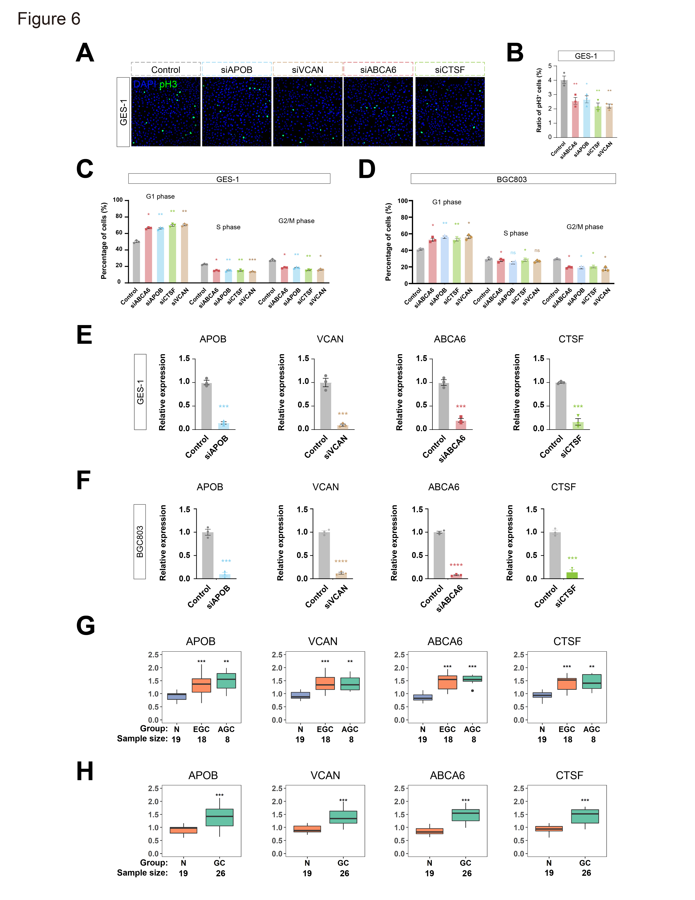

**Figure 6.** Knockdown of PRGS inhibited proliferation of gastric cancer cells. (A-D) Knockdown of any one of APOB, VCAN, ABCA6 or CTSF by siRNA inhibited cell proliferation of GES-1 and BGC803 gastric cancer cells. Shown are the anti-phosphorylated Histone 3 (pH3) immunostaining (A and B) and flow cytometry-based cell cycle assays (C-D) of upon APOB, VCAN, ABCA6 or CTSF siRNA treatment. For (A), scale bar, 10 μm. For (B)-(F), n = 3. one-way ANOVA, Tukey’s multiple comparison tests. In all figures, standard errors of the mean were represented. NS is not significant. *p < 0.05. **p < 0.01. ***p < 0.001. (G) BoxPlot of PRGS expression level in normal, early gastric cancer, and advanced gastric cancer patients. (H) BoxPlot of PRGS expression level in normal and gastric cancer patients. N means normal gastric tissues; EGC means early gastric cancer tissues; AGC means advanced gastric cancer tissues; GC means gastric cancer tissues.

3.5. The immune cell infiltration between the high- and low- PRGS patients

Immune-infiltrating cells in the tumor microenvironment (TME) can modulate the tumor phenotype. We assessed tumor purity, as well as stromal and immune scores using the ESTIMATE algorithm in TCGA target GTEx samples [22]. ESTIMATE generates three types of scores, namely stromal scores indicating the presence of stroma, immune scores representing the infiltration of immune cells, and ESTIMATE score which infers tumor purity. Samples with low tumor purity show high ESTIMATE scores [22]. The results demonstrated that stromal and immune cells significantly increased along with malignancy progression (from stage Ⅰ to Ⅳ). The ESTIMATE score also increased from stage Ⅰ to stage Ⅳ, whereas tumor purity decreased in higher grades (Figure 7A), in accordance with previous studies [45], which illustrated that lower tumor purity correlates with severer malignancy.

As expected, a high abundance of stromal cells and immune cells and low tumor purity were shown in the high-PRGS group (Figure 7A). Hence PRGS group is positively correlated with malignancy. To further chart the underlying immune cells, we implemented the CIBERSORT algorithm to infer the differential abundance between the high- and low- PRGS patients [46]. The high-PRGS group has a great high level of naïve B cells (p=0.00014), monocytes (p=0.0312), M2 macrophage (p=1.6e-5), and mast cells resting (p=5.6e-5) (Figure 7B). Whereas, T follicular helper cell (p=3.9e-7), Treg (p=2.1e-6), resting NK cell (p=0.00716) and activated mast cells (p=0.03602) exhibited consistent negative correlation with low- PRGS group. Then, we determined whether those mentioned above infiltrating immune cells could be associated with patient survival. In agreement with previous researches indicating promoting roles of M2 macrophage cells in tumor progression [47] and naïve B cells when they differentiate into Breg cells in the tumor microenvironment, participating in tumor metastasis [48], we discovered that the naïve B cell, M2 macrophage cells were appeared to be associated with the poor survival (Figure 7C-D), in consistency with PRGS groups. In addition, the regulatory T cells (Treg), T follicular helper (Tfh) cells, and M0 macrophage cells showed a negative correlation with patient survival (Figure 7E-F), which accords with low PRGS group, where there are more Treg and Tfh cells than the high-PRGS group. Together, our data indicate that the high- PRGS group is characterized by a TME with high immune cell infiltration and low tumor purity.

3.6. Mutation status in GC patients in the high- and the low-PRGS groups

To investigate PRGS-related mechanisms in GC, we also analyzed somatic mutations. When comparing the mutant frequency between samples of the low- and the high-PRGS groups, we detected more mutations in the low-PRGS group than high-PRGS group, indicating that more mutations lead to lower PRGS and GC risk (Figure 7G). Past researches have revealed sophisticated correlations between mutations and tumor prognosis, e.g. TP53 mutations have significant associations with poor outcomes in Kidney Renal Clear Cell Carcinoma, Head and Neck Squamous Cell Carcinoma, and Acute Myeloid Leukemia as well as improved outcomes in Ovarian Serous Cystadenocarcinoma [49]. Besides, IDH1 and MUC16 mutations are associated with improved prognosis in gastric cancer [49-53]. All of the top20 frequent mutations were significantly enriched in cases with patients in both groups (Figure 7G). As a reference, we utilized GCscore [6] as feature genes (FANCA, DUSP3, HIST1H3B, CLNS1A, FANCC) to classify GC patients in the TCGA dataset into high- and low-risk group (Figure S17A). The top20 genes with the highest mutation frequencies also have relatively higher mutation frequencies in the low-risk group than in the high-risk group (Figure S17B). This result exhibits a similar tendency as our PRGS. We also found that MUC16(p=0.051), CSMD1(p=0.054), and FAT4(p = 0.033) mutants have better outcomes than wild type (WT), while TP53 and TTN, genes with the highest mutation frequencies, didn’t show differences in outcomes between their mutants and WT (Figure S17C-G). Frequent mutations in TNN, TP53, and MUC16 were significantly enriched in high- and low- PRGS groups, which are within expectations as previous reports [54].

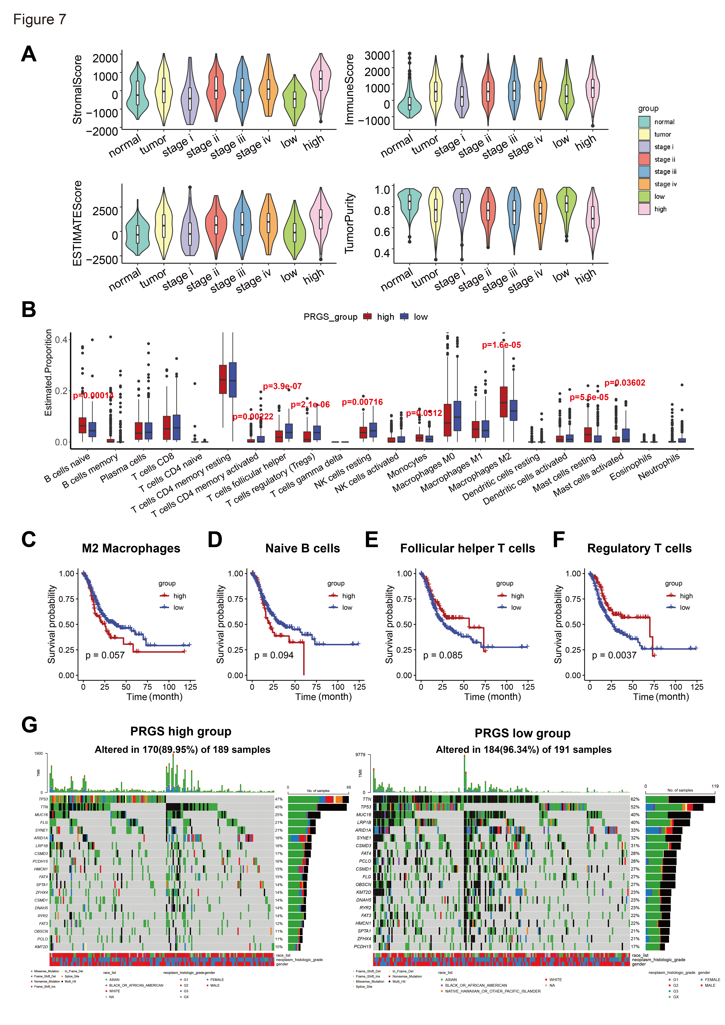

**Figure 7.** The landscape of immune infiltrations and tumor mutation status in the low- and high-PRGS groups. (A) Distinct distribution of stromal score (left upper), immune score (right upper), ESTIMATE score (left lower) and tumor purity (right lower) among GC patients in TCGA target GTEx. (B) The immune-infiltrating cells in the TME were determined based on the CIBERSORT algorithm in the TCGA target GTEx. (C)-(F) Kaplan–Meier curves of OS according to the M2 macrophage(C), naïve B cells(D), follicular helper T cells(E), and regulatory T cells(F) in TCGA target GTEx. (G) OncoPlot of significantly mutated genes in high-(left) and low-(right) PRGS groups. The mutation types with their frequencies were presented.

Additionally, APOB portrayed a mutation percentage of 8% and 18% in patients of high and low-PRGS groups, respectively. The mutation percentage for VCAN is 6% and 10% in high and low-PRGS groups; for ABCA6, it's 2% and 3%; and for CTSF, it's 1% and 3% (Figure S18A). Previous work [55] has reported APOB and VCAN as mutation driver genes.

Moreover, we observed significant co-occurrences among mutations of these genes. Among the top20 genes with the highest mutation probabilities in gastric cancer, a majority of these mutations of genes are co-occurring. Mutations of genes in the low-PGRS group display more significant co-occurrence than the high-PRGS group (Figure S18B). There are also gene pairs that are mutually exclusive. For example, previous researches have reported that ARID1A mutant tumors display p53 pathway activation, and ARID1A directly regulates TP53 target genes [56-57]; our analysis also displayed that in the high-PRGS group, TP53 and ARID1A mutations are significantly mutually exclusive. On the other hand, within the low-PRGS group, KMT2D, and FAT4 are also significantly mutually exclusive along with the previous two. These results also indicate a possible pair of mutually exclusive mutations in patients within the low-PRGS group.

Somatic mutations were further explored on the basis of oncogenic signaling pathways. We summarized genes’ expression levels and mutations from common oncogenic signaling pathways from patients of the high-PRGS group and low-PRGS group. For instance, disturbing the hippo pathway promotes GC proliferation and metastasis [58], and dysregulation of the MAPK pathway promotes cell metabolism, proliferation, apoptosis, and migration [59]. Our result also indicated that Hippo and MAPK pathways have high mutation percentages in both pathways and samples for high-PRGS and low-PRGS groups (Figure S18C). We discovered that for the most investigated cancer pathways, the patients from the high-PRGS group had higher pathway enrichment scores than the patients in the low-PRGS group (Figure S18D). Yet, the percentage of patients with mutations is lower in high-PRGS group than low-PRGS group, which might arise from other molecular mechanisms.

4. Discussion

To date, there are rarely effective prognostic genes for detecting and predicting gastric cancer prognosis. There is a noticeable difference among GC in the cardiac zone, the fundus/corpus zone, and the pyloric zone. However, researchers might neglect some significant genes when considering mixed data. Hence, we constructed co-expression networks of GC in these three zones separately to select the prognostic genes and build the PRGS. Different treatment options mean that patients need better-individualized evaluations when implementing clinical decisions. These can be used as reliable biomarkers for the diagnosis of "high-risk" GC patients.

In this study, WGCNA and Cytoscape, were applied to identify the gene co-expression network of GC in the cardiac zone, the fundus/corpus zone, and the pyloric zone. With the expression profiles of these genes in TCGA target GTEx and two independent datasets, the LASSO Cox regression model was applied to develop a prognostic gene signature. The prognostic analysis demonstrated that this PRGS was a deleterious indicator of OS. Besides, the PRGS represented high accuracy and consistent performance in TCGA target GTEx. We also performed cross-validation in two independent GEO datasets (GSE66229, GSE15459), which indicated great potential for the clinical application of PRGS.

The common tools for evaluating clinical outcomes and making therapeutic schedules including T, N, M, and clinical stages [4]. Remarkably, our signature worked independently of these factors and had vastly superior performance predicting prognosis. Besides, we took the PRGS as features to classify GC and normal samples with machine learning classifiers. All of the classification accuracy based on PRGS signature as features were highest with independent datasets (GSE66229) and several clinic stages (Stage Ⅰ, Ⅱ, Ⅲ, Ⅳ).

There are a number of prognostic gene signature based on characteristics genes, such as stem cell-related gene signature [6], DNA methylation-related gene signature[42]. These gene signatures overlooked the difference between the tumor location. Although several of these signatures have been developed, few have been implemented in clinical experiments and even fewer have undergone rigorous validation. We compared PRGS with these signatures to classify GC patients and PRGS has a better performance than other signatures. To further confirm the clinical significance of PRGS, we conducted a validation assay using qRT-PCR on 45 frozen gastric cancer tissues. This result further supports the validity of PRGS as a clinical marker. Consequently, our signature has the potential to be a useful clinical tool for the prognosis of GC.

To further test the clinical explanation of the PRGS, experimental validation was based on IHC results from different clinical stages independent GC patients, validating our prior findings and assessing their feasibility. It indicated that the protein expression level of the PRGS signature is significantly higher in GC patients. This conclusion was further experimentally validated in GES-1 and BGC803 gastric cancer cells, as the knockdown of these four genes led to cell growth inhibition by regulating cell cycle. Hence, the PRGS signature could serve as a promising surrogate for assessing the prognosis of GC in clinical settings.

Pathologists generally determine tumor purity by visual evaluation, which is affected by the sensitivity of histopathology, interobserver bias, and variability in accuracy [60]. Our results show that the high- PRGS group patients performed lower tumor purity and higher levels of immune and stromal cell infiltration compared with patients in the low-PRGS group. Previous researches have reported that tumor cells can dominate the microenvironment [60], and give rise to the hypothesis that malignant GC recruit abundant surrounding cells and subjugates them to compose a protective shield. Therefore, lower tumor purity and correlated cellular heterogeneity may contribute to the worse prognosis of GC. In our study, we found that PRGS was positively correlated with several infiltration cells, such as M2 macrophage and naïve B cells, which are positively correlated with the prognosis of GC patients; and negatively correlated with follicular helper T cells, M0 macrophage and regulatory T cells, which are negatively correlated with the prognosis of GC patients.

We found that GC patients in the low-PRGS group had a higher oncogenic mutation. It should be noted that the association of gene mutations with cancer outcomes is sophisticated. Take MUC16 and IDH1 as examples, past GC researches have illustrated that MUC16 mutations could activate the p53 pathway and DNA repair pathway, which are all tumor suppressor pathways [50-51], thus improved outcomes of GC might be expected from mutated MUC16[35-36]; mutations in IDH1, as a tumor suppressor in human glioma cells by negatively regulating Wnt/β-catenin signaling, improves survival conditions [52-53]. And the mutation of the top20 genes had a high frequency of co-mutations. However, further investigations are needed for a deep understanding of the mechanisms of mutations in GC.

5. Conclusions

In a word, based on a series of bioinformatics, machine learning-based algorithms and experimental validation, we developed a powerful and robust signature for assessing the prognosis of GC patients. This PRGS model may be a promising tool for screening and monitoring individual GC patients.

Supplementary Materials: The following supporting information can be downloaded at: www.mdpi.com/xxx/s1, Figures S1-S18; Supplementary Figure legends; Supplementary Tables1-13

**Author Contributions:** Conception and design: M.Q.Z., C.C.L., X.Y.L.; Experimental operation: Y.S.Z.; Collection and assembly of data: C.C.L., X.Y.L., Y.Y.H.; Provision of materials or patients’ information: P.J., F.M.Y.; Manuscript writing and revision: M.Q.Z., C.C.L., X.Y.L., M.L.S., Y.Y.H., Y.S.Z., P.J., F.M.Y., T.Y.C., Z.Y.W., J.T.G.; All authors read and approved the final manuscript.

**Funding:** Please add: This work was funded by the National Key Research and Development Program of China [2017YFA0505503]; Natural Science Foundation of China[62003028]; Fundamental Research Funds for the Central Universities [2019RC045].

**Institutional Review Board Statement:** Not applicable

**Informed Consent Statement:** In this study, the gastric tissues used were approved by the Department of Gastroenterology, Seventh Medical Center of Chinese PLA General Hospital, Beijing, China, on June 1st, 2022. Overall, one advanced GC sample, an early GC sample, and a normal gastric sample were collected. All patients provided written informed consent, and Ethnics committee of PLA General Hospital has also approved our research. Relevant documents have been uploaded as supplementary materials.

**Data Availability Statement:** The datasets that support the findings of this study are available from the Cancer Genome Atlas TARGET and Genotype Tissue Expression project datasets (TCGA target GTEx, primary_site = stomach) and NCBI Gene Expression Omnibus (GEO) under accession numbers GSE66229, GSE15459.

Acknowledgments: We thank Dr.Jianming Zeng(University of Macau), and all the members of his bioinformatics team, and biotrainee, for generously sharing their experience and codes. The Use of the biorstudio high-performance computing cluster(https://biorstudio.cloud) at Biotrainee and The shanghai HS Biotech Co.,Ltd for conducting the research reported in this paper.

We thank Prof. Jun Qin and Xianju Li, Beijing Proteome Research Center, for giving the gastric cancer cell line GSE-1.

We thank Zijie Shen from College of Agriculture & Biotechnology, Zhejiang University, Dr. Haotian Wang from Kunming Institute of Zoology, CAS, and Dr. Wenbo Guo, Department of Automation, Tsinghua University for data processing.

**Conflicts of Interest:** The authors declare no conflict of interest.

References

1. Sung H, Ferlay J, Siegel R L, et al. Global cancer statistics 2020: GLOBOCAN estimates of incidence and mortality worldwide for 36 cancers in 185 countries[J]. CA: a cancer journal for clinicians, 2021, 71(3): 209-249.
2. Fong C, Johnston E, Starling N. Neoadjuvant and Adjuvant Therapy Approaches to Gastric Cancer[J]. Current Treatment Options in Oncology, 2022: 1-22.
3. Wittekind C. The development of the TNM classification of gastric cancer[J]. Pathology international, 2015, 65(8): 399-403.
4. Egner J R. AJCC cancer staging manual[J]. Jama, 2010, 304(15): 1726-1727.
5. Shimada H, Noie T, Ohashi M, et al. Clinical significance of serum tumor markers for gastric cancer: a systematic review of literature by the Task Force of the Japanese Gastric Cancer Association[J]. Gastric cancer, 2014, 17(1): 26-33.
6. Wei C, Chen M, Deng W, et al. Characterization of gastric cancer stem-like molecular features, immune and pharmacogenomic landscapes[J]. Briefings in Bioinformatics, 2022, 23(1): bbab386.
7. Cui K, Yao S, Liu B, et al. A novel high-risk subpopulation identified by CTSL and ZBTB7B in gastric cancer[J]. British Journal of Cancer, 2022: 1-11.
8. Cheong J H, Wang S C, Park S, et al. Development and validation of a prognostic and predictive 32-gene signature for gastric cancer[J]. Nature communications, 2022, 13(1): 1-9.
9. Helander H F. The cells of the gastric mucosa[J]. International review of cytology, 1981, 70: 217-289.
10. Hoffmann W. Regeneration of the gastric mucosa and its glands from stem cells[J]. Current medicinal chemistry, 2008, 15(29): 3133-3144.
11. Hoffmann W. Current status on stem cells and cancers of the gastric epithelium[J]. International journal of molecular sciences, 2015, 16(8): 19153-19169.
12. Lai S. A human mode of intestinal type gastric carcinoma[J]. Medical Hypotheses, 2019, 123: 27-29.
13. Vivian J, Rao A A, Nothaft F A, et al. Toil enables reproducible, open source, big biomedical data analyses[J]. Nature biotechnology, 2017, 35(4): 314-316.
14. Chen H M, MacDonald J A. Network analysis of TCGA and GTEx gene expression datasets for identification of trait-associated biomarkers in human cancer[J]. STAR protocols, 2022, 3(1): 101168.
15. Law C W, Alhamdoosh M, Su S, et al. RNA-seq analysis is easy as 1-2-3 with limma, Glimma and edgeR[J]. F1000Research, 2016, 5.
16. Langfelder P, Horvath S. WGCNA: an R package for weighted correlation network analysis[J]. BMC bioinformatics, 2008, 9(1): 1-13.
17. Shannon P, Markiel A, Ozier O, et al. Cytoscape: a software environment for integrated models of biomolecular interaction networks[J]. Genome research, 2003, 13(11): 2498-2504.
18. Chin C H, Chen S H, Wu H H, et al. cytoHubba: identifying hub objects and sub-networks from complex interactome[J]. BMC systems biology, 2014, 8(4): 1-7.
19. Tibshirani R. The lasso method for variable selection in the Cox model[J]. Statistics in medicine, 1997, 16(4): 385-395.
20. Wilkerson M D, Hayes D N. ConsensusClusterPlus: a class discovery tool with confidence assessments and item tracking[J]. Bioinformatics, 2010, 26(12): 1572-1573.
21. Shen Y, Vignali P, Wang R. Rapid profiling cell cycle by flow cytometry using concurrent staining of DNA and mitotic markers[J]. Bio-protocol, 2017, 7(16): e2517-e2517.
22. Yoshihara K, Shahmoradgoli M, Martínez E, et al. Inferring tumour purity and stromal and immune cell admixture from expression data[J]. Nature communications, 2013, 4(1): 1-11.
23. Newman A M, Steen C B, Liu C L, et al. Determining cell type abundance and expression from bulk tissues with digital cytometry[J]. Nature biotechnology, 2019, 37(7): 773-782.
24. Mayakonda A, Lin D C, Assenov Y, et al. Maftools: efficient and comprehensive analysis of somatic variants in cancer[J]. Genome research, 2018, 28(11): 1747-1756.
25. Yu G, Wang L G, Han Y, et al. clusterProfiler: an R package for comparing biological themes among gene clusters[J]. Omics: a journal of integrative biology, 2012, 16(5): 284-287.
26. Hänzelmann S, Castelo R, Guinney J. GSVA: gene set variation analysis for microarray and RNA-seq data[J]. BMC bioinformatics, 2013, 14(1): 1-15.
27. Friedman J, Hastie T, Tibshirani R. glmnet: Lasso and elastic-net regularized generalized linear models[J]. R package version, 2009, 1(4): 1-24.
28. Kumar V, Ramnarayanan K, Sundar R, et al. Single-Cell Atlas of Lineage States, Tumor Microenvironment, and Subtype-Specific Expression Programs in Gastric Cancer[J]. Cancer discovery, 2022, 12(3): 670-691.
29. Takaya K, Asou T, Kishi K. Cathepsin F is a potential marker for senescent human skin fibroblasts and keratinocytes associated with skin aging[J]. GeroScience, 2022: 1-11.
30. Smith K R, Dahl H H M, Canafoglia L, et al. Cathepsin F mutations cause Type B Kufs disease, an adult-onset neuronal ceroid lipofuscinosis[J]. Human molecular genetics, 2013, 22(7): 1417-1423.
31. Borgquist S, Butt T, Almgren P, et al. Apolipoproteins, lipids and risk of cancer[J]. International journal of cancer, 2016, 138(11): 2648-2656.
32. Hedditch E L, Gao B, Russell A J, et al. ABCA transporter gene expression and poor outcome in epithelial ovarian cancer[J]. JNCI: Journal of the National Cancer Institute, 2014, 106(7).
33. Timms K P, Maurice S B. Context-dependent bioactivity of versican fragments[J]. Glycobiology, 2020, 30(6): 365-373.
34. Song W, Qin L, Chen Y, et al. Single-cell transcriptome analysis identifies Versican (+) myofibroblast as a hallmark for thoracic aortic aneurysm marked by activation of PI3K-AKT signaling pathway[J]. Biochemical and Biophysical Research Communications, 2022.
35. Chida S, Okayama H, Noda M, et al. Stromal VCAN expression as a potential prognostic biomarker for disease recurrence in stage II–III colon cancer[J]. Carcinogenesis, 2016, 37(9): 878-887.
36. Kassambara A, Kosinski M, Biecek P, et al. Package ‘survminer’[J]. Drawing Survival Curves using ‘ggplot2’(R package version 03 1), 2017.
37. Șenbabaoğlu Y, Michailidis G, Li J Z. Critical limitations of consensus clustering in class discovery[J]. Scientific reports, 2014, 4(1): 1-13.
38. Beauchemin N, Arabzadeh A. Carcinoembryonic antigen-related cell adhesion molecules (CEACAMs) in cancer progression and metastasis[J]. Cancer and Metastasis Reviews, 2013, 32(3): 643-671.
39. Geng H, Dong Z, Zhang L, et al. An immune signature for risk stratification and therapeutic prediction in helicobacter pylori-infected gastric cancer[J]. Cancers, 2022, 14(13): 3276.
40. Luo S, Lin R, Liao X, et al. Identification and verification of the molecular mechanisms and prognostic values of the cadherin gene family in gastric cancer[J]. Scientific Reports, 2021, 11(1): 1-21.
41. Hu B, Xie M, Li K, et al. Genome-wide analysis to identify a novel distant metastasis-related gene signature predicting survival in patients with gastric cancer[J]. Biomedicine & Pharmacotherapy, 2019, 117: 109159.
42. Li Y, Sun R, Zhang Y, et al. A methylation‐based mRNA signature predicts survival in patients with gastric cancer[J]. Cancer cell international, 2020, 20(1): 1-10.
43. Liu Y, Wu J, Huang W, et al. Development and validation of a hypoxia-immune-based microenvironment gene signature for risk stratification in gastric cancer[J]. Journal of translational medicine, 2020, 18(1): 1-17.
44. Chen J, Ou Y, Luo R, et al. SAR1B senses leucine levels to regulate mTORC1 signalling[J]. Nature, 2021, 596(7871): 281-284.
45. Zhang C, Cheng W, Ren X, et al. Tumor Purity as an Underlying Key Factor in GliomaTumor Purity in Glioma[J]. Clinical Cancer Research, 2017, 23(20): 6279-6291.
46. Newman A M, Steen C B, Liu C L, et al. Determining cell type abundance and expression from bulk tissues with digital cytometry[J]. Nature biotechnology, 2019, 37(7): 773-782.
47. Boutilier A J, Elsawa S F. Macrophage polarization states in the tumor microenvironment[J]. International journal of molecular sciences, 2021, 22(13): 6995.
48. [33] Sarvaria A, Madrigal J A, Saudemont A. B cell regulation in cancer and anti-tumor immunity[J]. Cellular & molecular immunology, 2017, 14(8): 662-674.
49. Kandoth C, McLellan M D, Vandin F, et al. Mutational landscape and significance across 12 major cancer types[J]. Nature, 2013, 502(7471): 333-339.
50. Li X, Pasche B, Zhang W, et al. Association of MUC16 mutation with tumor mutation load and outcomes in patients with gastric cancer[J]. JAMA oncology, 2018, 4(12): 1691-1698.
51. Huang Y J, Cao Z F, Wang J, et al. Why MUC16 mutations lead to a better prognosis: A study based on The Cancer Genome Atlas gastric cancer cohort[J]. World Journal of Clinical Cases, 2021, 9(17): 4143.
52. Myung J K, Cho H J, Park C K, et al. IDH1 mutation of gliomas with long-term survival analysis[J]. Oncology reports, 2012, 28(5): 1639-1644.
53. Yao Q, Cai G, Yu Q, et al. IDH1 mutation diminishes aggressive phenotype in glioma stem cells[J]. International journal of oncology, 2018, 52(1): 270-278.
54. Zhu Z, Fu H, Wang S, et al. Whole-exome sequencing identifies prognostic mutational signatures in gastric cancer[J]. Annals of Translational Medicine, 2020, 8(22).
55. Wang K, Yuen S T, Xu J, et al. Whole-genome sequencing and comprehensive molecular profiling identify new driver mutations in gastric cancer[J]. Nature genetics, 2014, 46(6): 573-582.
56. Reske J J, Wilson M R, Holladay J, et al. Co-existing TP53 and ARID1A mutations promote aggressive endometrial tumorigenesis[J]. PLoS Genetics, 2021, 17(12): e1009986.
57. Zang Z J, Cutcutache I, Poon S L, et al. Exome sequencing of gastric adenocarcinoma identifies recurrent somatic mutations in cell adhesion and chromatin remodeling genes[J]. Nature genetics, 2012, 44(5): 570-574.
58. Qiao Y, Li T, Zheng S, et al. The Hippo pathway as a drug target in gastric cancer[J]. Cancer Letters, 2018, 420: 14-25.
59. Magnelli L, Schiavone N, Staderini F, et al. MAP kinases pathways in gastric cancer[J]. International Journal of Molecular Sciences, 2020, 21(8): 2893.
60. Cohen D A, Dabbs D J, Cooper K L, et al. Interobserver agreement among pathologists for semiquantitative hormone receptor scoring in breast carcinoma[J]. American journal of clinical pathology, 2012, 138(6): 796-802.